**GDKN INTERVIEW EXPLAINATION**

**FIRST-NAME: ANANDHABALA LAST-NAME: A**

**COLLEGE-NAME: RVS COLLEGE OF ARTS AND SCIENCE**

**PERCENTAGE/GRADE: 95% percentage**

**DEGREE: MSC COMPUTER SCIENCE**

**YEAR AND SEMESTER : 2 YEAR / 3 semester**

**EMAIL-ID: anandhabala2@gmail.com**

**CONTACT-NO: 9787409574**

**TECHNICAL EXPERTISE : HTML & CSS & JAVASCRIPT &NODE.JS & REACT**

**TEST LINK : <https://github.com/Anandhabala/GDKN-INTERVIEW-TEST.git>**

**EXPLAINATION :**

**1. what is HTML & CSS?**

**ANS:**

**HTML:**

**in my explaination is HTML IS a programming language .HTML is a used to create web page.**

**if you intrested you can create whole game . its real if you believe the chrome its have no internet dragon game**

**its completed by the HTML you can add image,button,navigation,etc...**

**example:**

**<img id="dragon" src="dragonimage"></img>**

**CSS:**

**in my explaination CSS is designing language. its styling the html elements that means.example,the chrome no internet**

**dragon game is a play only black and white . if you intrested using id of dragon to color the orange and**

**red color for the dragon.**

**example:**

**#dragon:**

**height:30px;**

**width:40px;**

**color:orange;**

**backgroundcolor:red;**

**-----------------------------------------------------------------------------------------------------------------------------------------**

**2.what is bootstrap tell about it?**

**ANS:**

**bootstrap:**

**in my explaination bootstrap is similar of CSS using style your web page.but its reduce the work user because the bootstrap is already create the**

**so many designs in bootstrp its mainly used for students easily do copy paste method easy in this generation. because copy the design and impress your friends**

**use this bootstrap in your web page.**

**----------------------------------------------------------------------------------------------------------**

**3.insert your friends detail in table ?**

**Ans:**

**in html easily create table because every one create in html so many tags in HTML you use the tag to create your web page**

**in table you use the table tag <table> and you set the table header you use <th>,<td>cell spevify,<tr>row specify etc.**

**so many tags in table if you need you which style you need you can insert.**

**code:**

**<!DOCTYPE html>**

**<html lang="en">**

**<head>**

**<title>Table creation</title>**

**</head>**

**<style>**

**table,th,td {border: 1px solid gold;}**

**</style>**

**<body>**

**<table>**

**<tr>**

**<th>ANANDFRIEND</th>**

**</tr>**

**<tr>**

**<td>Raja</td>**

**</tr>**

**<tr>**

**<td>Ranjith</td>**

**</tr>**

**</table>**

**</body>**

**</html>**

**----------------------------------------------------------------------------------------------------------**

**4. code:**

**<!DOCTYPE html>**

**<html lang="en">**

**<head>**

**<title>Table creation</title>**

**</head>**

**<style>**

**table,th,td {color: blue; border: 1px solid gold;}**

**</style>**

**<body>**

**<table>**

**<tr>**

**<th>ANANDFRIEND</th><th>first-name</th><th>last-name</th><th>age</th><th>email-id</th>**

**</tr>**

**<tr>**

**<td>Raja</td><td>kasthuri</td><td>Raja</td><td>22</td><td>raja@gmail.com</td>**

**</tr>**

**<tr>**

**<td>Ranjith</td><td>Ranjith</td><td>kumar</td><td>23</td><td>ranjith@gmail.com</td>**

**</tr>**

**</table>**

**</body>**

**</html>**

**----------------------------------------------------------------------------------------------------------------**

**Question 5:**

**EXPLAIN:**

**Fixed means the object is not moved.but absolute is its screen wise is adjest the screen.**

**Output:**

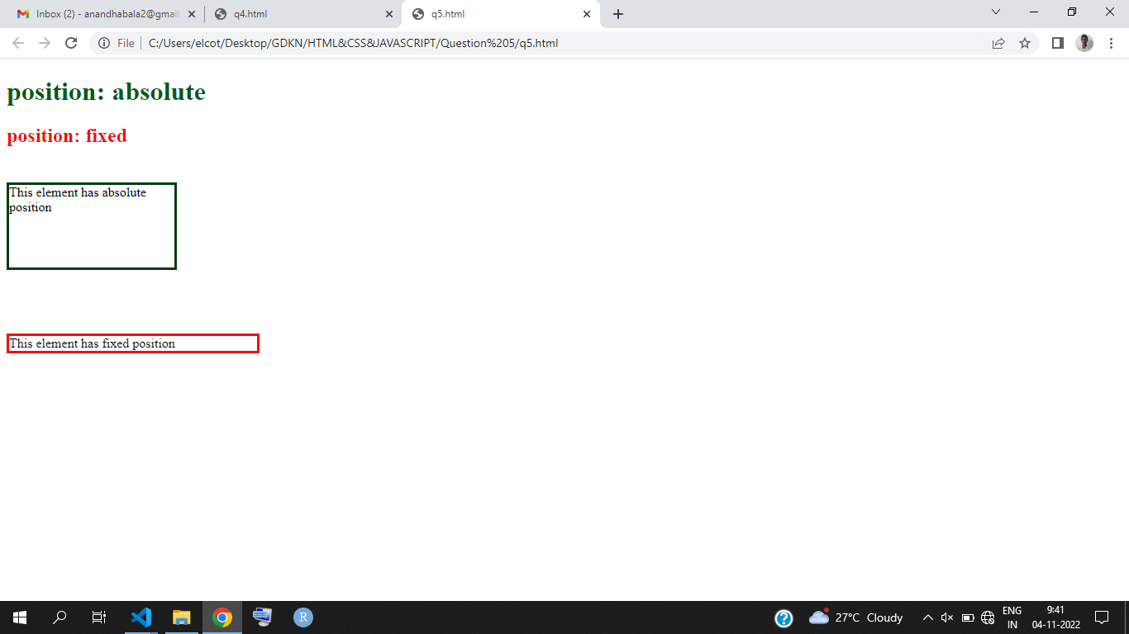

**Question 6:**

**EXPLAIN:**

**DIV IS CONTAINER inside of consider you can add the text.**

**The span is next line print the using the span.**

**Output:**

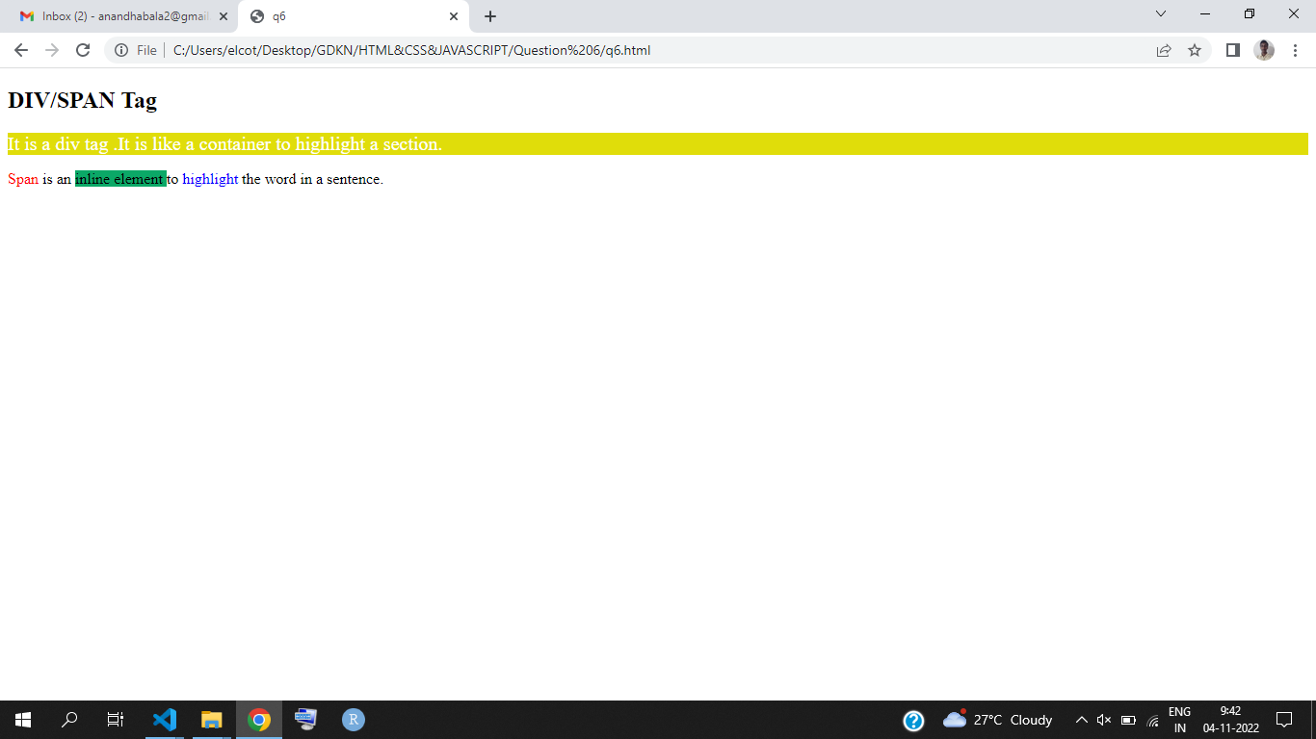

**Question 7:**

**EXPLAIN :**

**The used to the text is put in the head tag use metrix.**

**The used to the text is put in the multiple line use demetrix.**

**Output:**

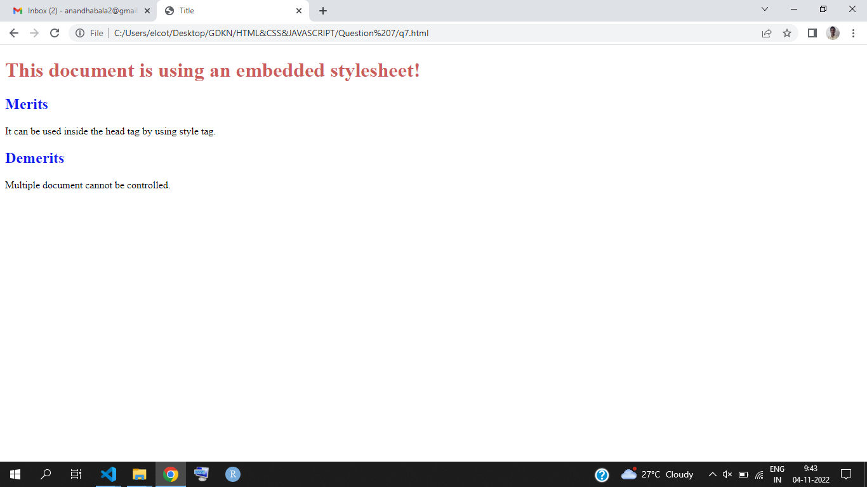

**Question 8:**

**EXPAIN:**

**If you link the hyper link the link is go to the link in browser.**

**Output:**

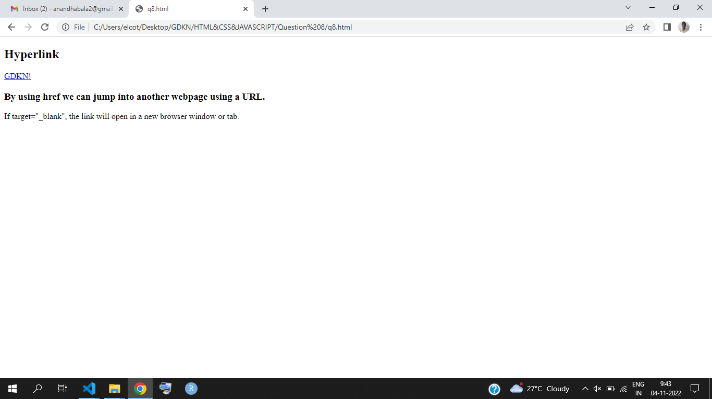

**Question 9:**

**Output:**

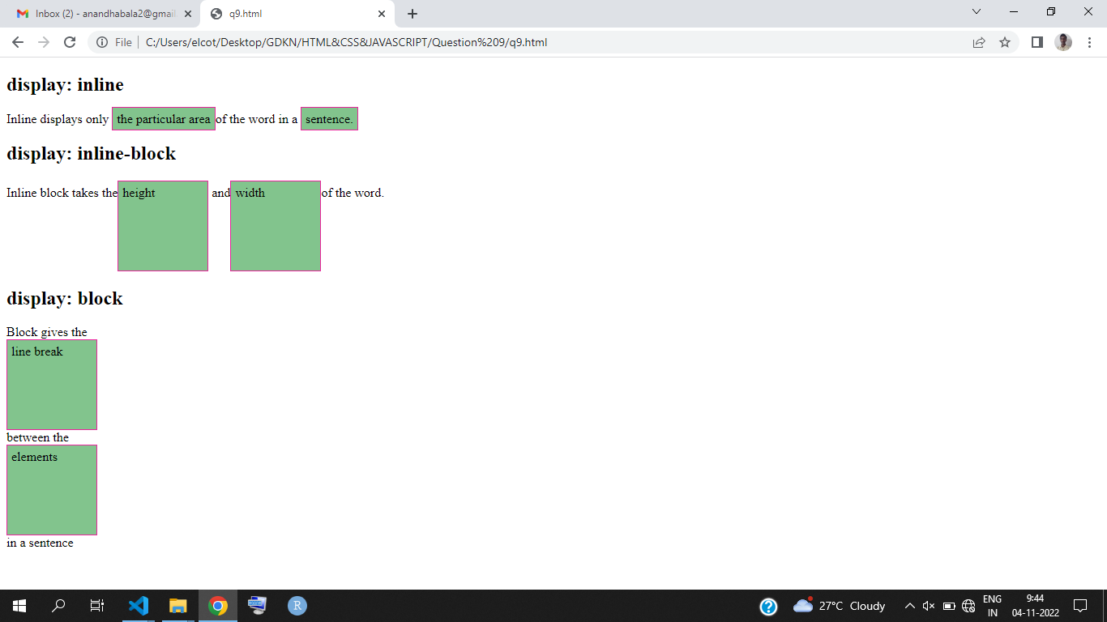

**Question 10:**

**Output:**

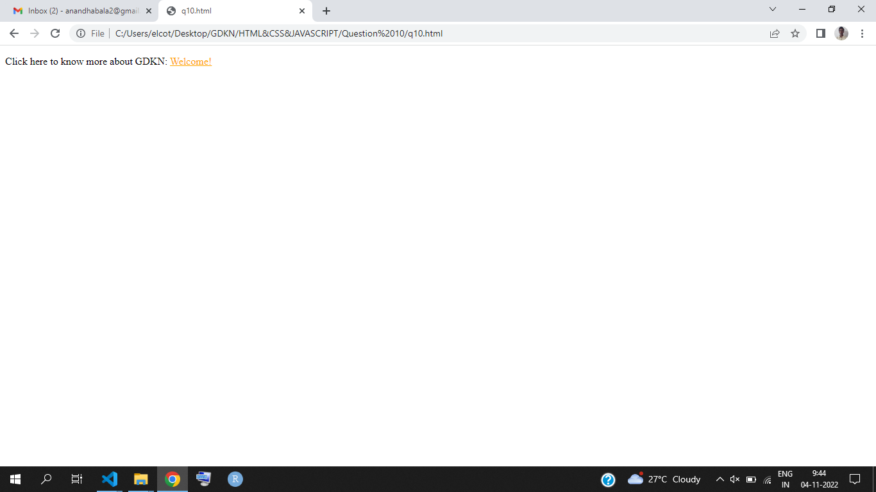

**Question 11:**

**Output:**

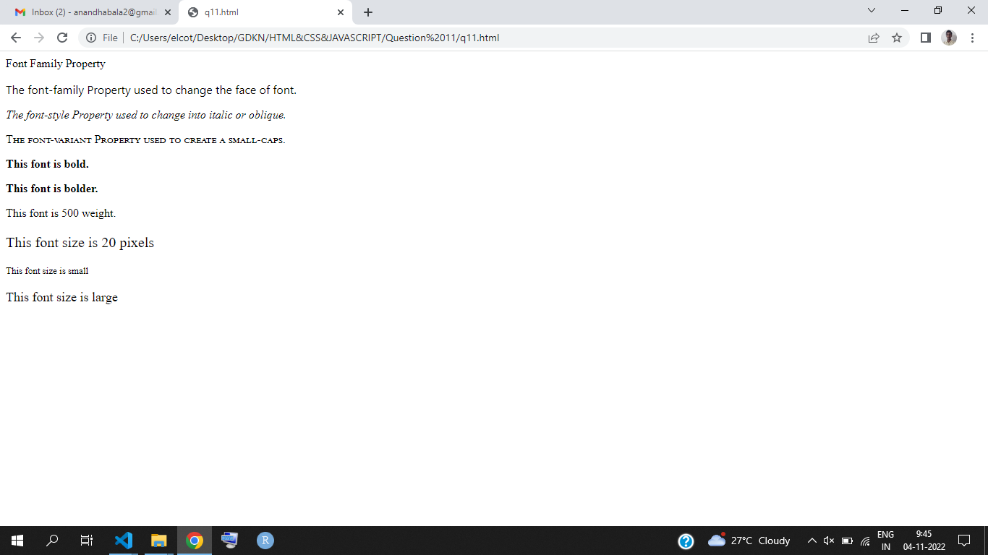

**Question 12 :**

**Output:**

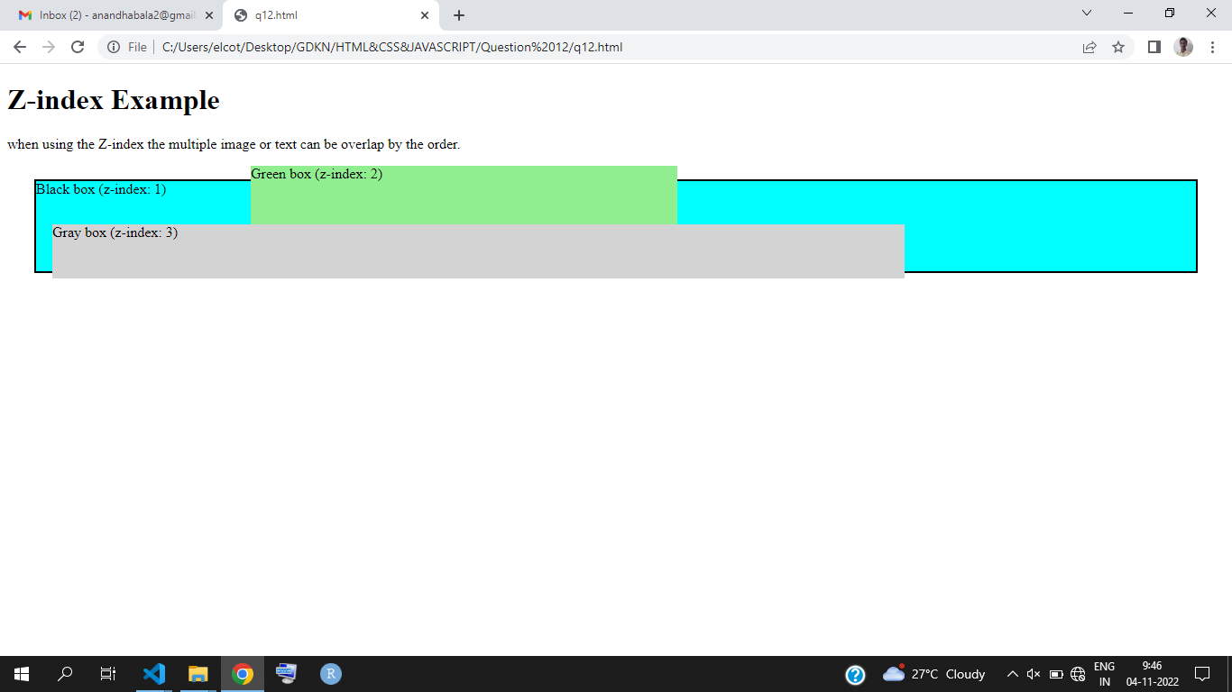

**Question 13 :**

**Output:**

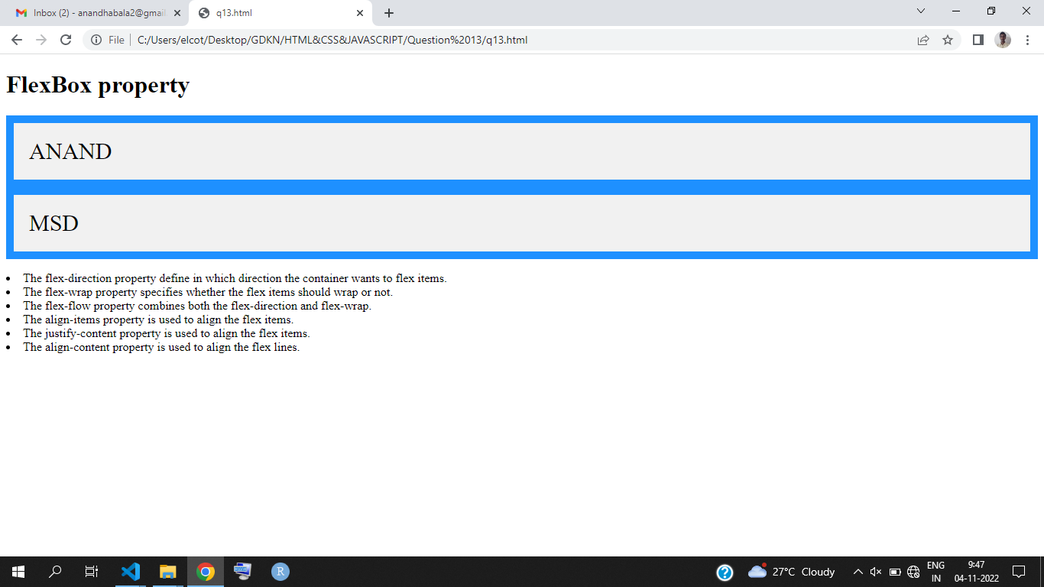

**Question 14 :**

**Output:**



